Part B:

1. explain the agile methodology of working and its purposes
Agile methodology is a project management framework that breaks projects down into several dynamic phases,it purposes to make the project much organised and has no conflict in it also git it in time

2. compare between agile and waterfall models : advantage, disadvantage, when to use it, best practice of both

models | advantage | disadvantage | when to use it | best practice of both
agile | The entire team is involved in the planning.  Feedback is central to the process.  Customers and stakeholders are involved. | Agile techniques and terminology can be tough to grasp.  It can take teams a while to learn proper agile methods.  Agile teams may not get the support they require from management and business owners. | When the project need flexibility | suited for projects with evolving requirements, allowing for continuous improvement and faster delivery
waterfall | Clear goals and objectives are provided at the outset.  There’s a straightforward structure that’s repeated project after project.  It’s easy for team members to understand what’s expected of them. | The process is not as flexible as agile approaches.  It’s difficult to foresee roadblocks and dependencies that could delay work.  Work is not always evenly spread out across the team. | When the project is linear and structured | Waterfall is good for projects with clear and stable requirements

3- state all the frameworks that you know are used for implementing agile:
- Kanban
- Scrum
- Lean
- DSDM
- XP
- FDD
- Crystal

4-explain in detail the scrum framework for agile : timing, meetings, roles

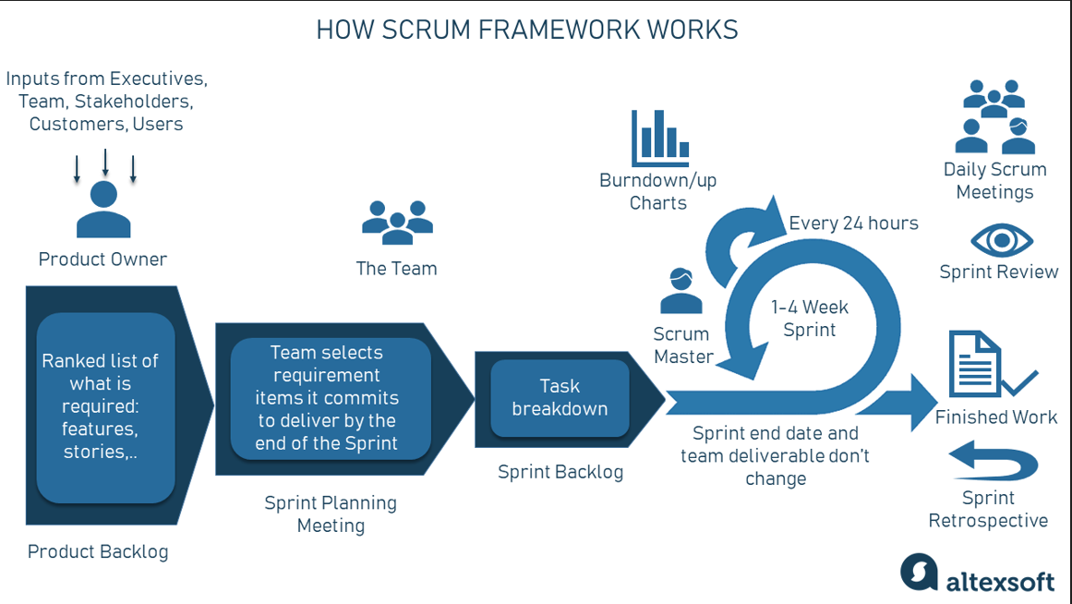
Scrum is a way to manage work by breaking it into small steps. First, the Product Owner collects ideas and creates a list of tasks (Product Backlog). The team picks some tasks to work on in a short period called a Sprint (1-4 weeks) during a Sprint Planning Meeting. These tasks are broken into smaller parts (Sprint Backlog) and completed during the Sprint. Every day, the team has a short meeting (Daily Scrum) to check progress, and the Scrum Master helps solve problems. Progress is tracked using Burndown Charts, and at the end of the Sprint, the team reviews the finished work (Sprint Review) and discusses improvements (Sprint Retrospective). This cycle repeats until the project is complete.

References :
https://www.easyagile.com/blog/agile-vs-waterfall

https://www.geeksforgeeks.org/agile-vs-waterfall/

